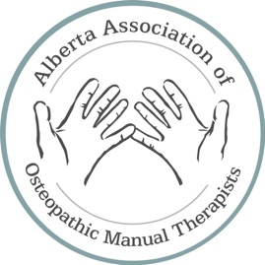

AAOMT Complaint Form
Please send the following information to ethics@osteopathyalberta.com in order to submit a complaint against an active Alberta Association of Osteopathic Manual Therapists member.

Your Contact Information
Full Name:
Street Address:
City:
Province:
Postal Code:
Phone Number:
Email Address:

Complaint Information
AAOMT Member’s Name:
AAOMT Member’s Business Name:
Business Address:
City:

Incident
What is the nature of your complaint?
- Competence
- Conduct
- Other

The Incident
Please describe the incident(s) that led to your concern(s) about the AAOMT Member, including when and where the incident(s) occurred.

Witness Information
Please provide the names and contact details of anyone who witnessed or may have relevant information about the incident(s) detailed in this complaint.

Action taken to date
Please describe what action you have taken to try to resolve your concern/complaint. Include the name(s) of anyone you have contacted and describe any action(s) taken by other people.

Have you reported the incident(s) to any other organization:
Has the incident been reported to a Regulatory College?

- No
- Yes
If yes, please name:

Has the incident been reported to the police?

- No
- Yes
If yes, please provide details

If you answered yes to any of the above, has that organization acted on the concern/complaint?

- No
- Yes
If yes, what was the result of these actions?

Your Desired Outcome
Please describe your desired outcome

Authorizing an AAOMT Representative

Complaint Date: Month/Day/Year

Please indicate in your email that you are agreeing to the following:
I give permission for a representative of the AAOMT to contact me, the witnesses/observers to the incident(s) and to provide the named AAOMT member (if an active member) with this complaint. The AAOMT is authorized to send the completed form to any other relevant associations or regulatory colleges (if applicable). The AAOMT is authorized to obtain a copy of my treatment file from the AAOMT member in question.

If you have any documents related to your complaint, please preserve the originals and send copies to: ethics@osteopathyalberta.com

